Software Requirements Specification

Tutoring Online Application

**Version 1.1 approved**

**Prepared by**

**Group 8**

***Group Member***

***</ Le Danh Trong***

***Nguyen Dang Hai Anh***

***Le Doan My Nhung***

***Linh />***

**Ho Chi Minh, 2022**

Table of Contents

Table of Contents 2

Revision History .

1. Introduction

1.1 Purpose 3

1.2 Document Conventions 3

2. Overall Description

2.1 Product Perspective 4

2.2 User Classes and Characteristics 5

2.3 Operating Environment 5

2.4 Design and Implementation Constraints 5

2.5 Assumptions and Dependencies 5

3. System Features

3.1 Use case diagram ………………………………………….6

3.2 System Feature 1………………………………………………………………….………………………………….15

3.3 System Feature 2 (and so on)……………………………………………………….………………………………..19

4. Data Requirements

4.1 Logical Data Model………………………………………………………………….……………………………….21

4.2 Data Dictionary 22

4.3 Reports 26

4.4 Data Acquisition, Integrity, Retention, and Disposal 26

5. External Interface Requirements

5.1 User Interfaces 27

5.2 Software Interfaces 27

5.3 Hardware Interfaces 27

5.4 Communications Interfaces 27

6. Quality Attributes

6.1 Usability 27

6.2 Performance 27

6.3 Security 28

6.4 Safety 28

7. Internationalization and Localization Requirements

8. Other Requirements .

Appendix A: Glossary

Appendix B: Analysis Models

# **Introduction**

Students have many problems related to study.Students want find a website to study online. If have, students will go far, traffic jams, tiring. Difficulty in accessing good tutors, tutors are far away. It is difficult to determine the quality of tutors. In that context, we developed a project that allows finding online tutors. Parents and students can actively choose tutors according to their own wishes, helping to choose the most favorable study time known as *Tutoring Online Application*

## Purpose

We came up with an idea for an application, where students could search for the tutor who want learn with them, view detail a course, view schedule, syllabuses, lesson, book syllabus…. At the side of tutors, they could view schedule, search, edit class. Such an application could help students for timely support, and it would increase interactive ability between tutor and students. Therefore, the application would give the convenient and effective, optimize for students and tutors

## Document Conventions

No special typographical conventions are used in this SRS.

# **Overall Description**

## Product Perspective

The application would be updated to the latest version. We have plans in the future will to develop products that could work on many different devices: IOS, iPad, Android, etc..by setting configuration changes that are more suited to a production environment. Besides, the application could extend to other tutoring center.

## User Classes and Characteristics

For **students** who want to get help from tutors. The Tutoring Online Application is a system that would help students easily search for their needs, make a booking syllabus, view schedule, search syllabus. Unlike the present, when students take a long time to find website tutor online suitable, our product could help students save their time, increase their choices and thereby achieve their goals.

For **tutors** who need to find a foundation to teach for students. The Tutoring Online Application is a system that would help tutors view schedule, view edit profile, join room by google meet to teach, etc. Unlike the present, our product could help lecturers easily manage their free time, view details schedule before the meeting for better preparation.

For **guests** who want to experience the website. The Lecturer Appointment Scheduling Application is a system that would help guests sign up an account, search for tutors, lessons before they sign in, etc. Unlike the present, our product would help guest save time easy to search

For **admin** who need to manage the system. The Lecturer Appointment Scheduling Application is a system that offer tools for management like category, syllabus, subject, payment or search syllabus, etc. Unlike the present, our product would help admin easy to information management.

# **System Features**

## Database Diagram

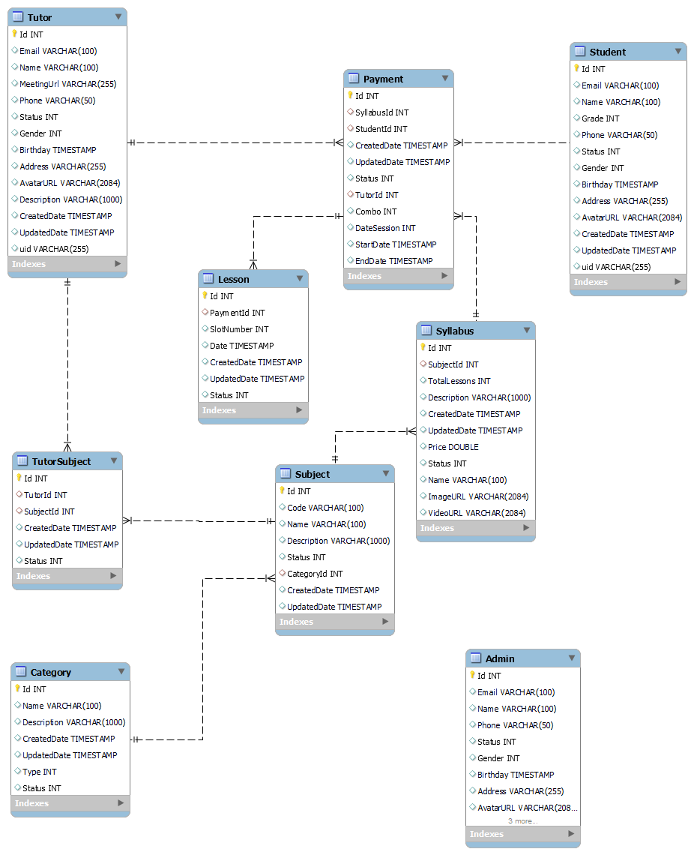

## Use case Diagram

## Logical Data Model

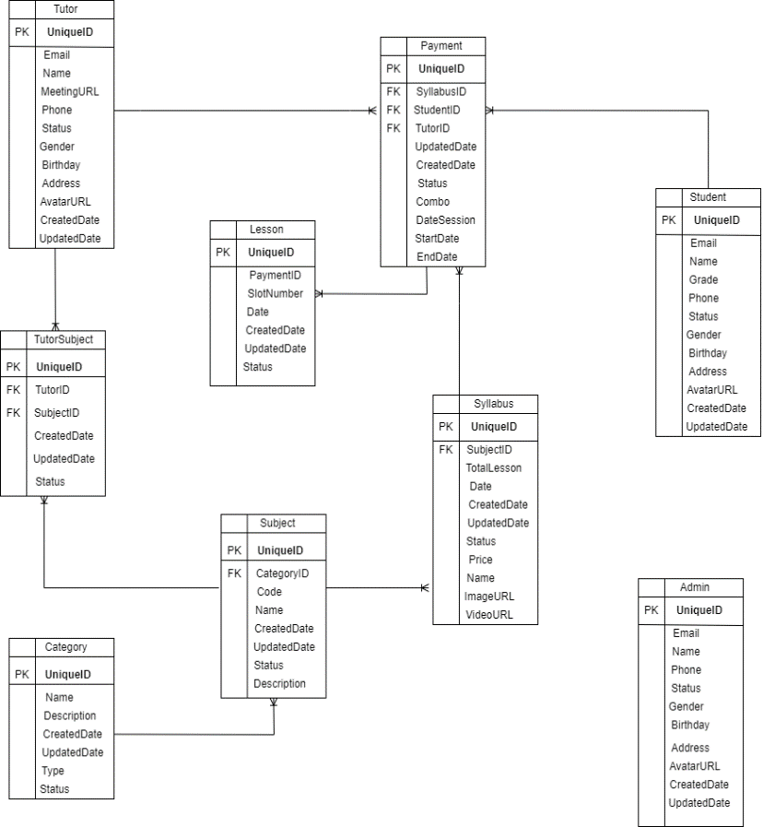

## State Chart Diagram

## Some use cases

|  |  |
| --- | --- |
| **Primary Actor** | **Use case** |
| **Guest** | 1. Sign-in. 2. Sign up 3. Search syllabus |
| **Authentication User** | 1. Edit profile 2. View profile 3. Search syllabus |
| **Student** | 1. Book syllabus 2. View class schedule |
| **Tutor** | 1. View tutor schedule |
| **Admin** | 1. Management information   (category, syllabus,…) |

**Use Cases**

Sign up

|  |  |  |  |
| --- | --- | --- | --- |
| ID and Name: | **UC - 1 Sign up** | | |
| Created By: | Trong | Date Created: | 19/05/2022 |
| Primary Actor: | Guest | Secondary Actors: | System |
| Description: | Guest visits the application through the website to search syllabus, then he/she wants to register a course, but the service needs sign-in before can be used. This use case allows guest to sign in to the system. | | |
| Trigger: | A guest decides to sign in to use the service. | | |
| Preconditions: | PRE-1. The guest is not signed into the application. | | |
| Postconditions: | POST-1. The guest is authenticated user, then system display the welcome page. | | |
| Normal Flow: | **1. Sign up**   1. The user goes to the sign-in page. 2. The system prompts the user for username and password or the “Sign-in with Google account” button. 3. The guest selects “Sign-in with Google account” as student or lecturer, or enters username and password if he/she is admin. 4. The system does validate. 5. Guest is signed in and returned to the service page as authenticated User. | | |
| Alternative Flows: | 4.1.This is the first-time guest signs in:  - The system will ask for permission to get her/his details for the sign-up process.  - Back to step 2 to resign-in. | | |
| Exceptions: | 4.2. Admin user enters an invalid username or password:  1. The system alerts the reasons why failed.  2. The system prompts the user to resign again in step 2.  4.3. Email or account got ban:  1.The system alerts the account is got ban.  2. The system does not allow access, then back to step 2. | | |
| Priority: | High | | |
| Frequency of Use: | None. | | |
| Business Rules: | BR-2: Any admin account must be a local account.  BR-3: User must sign up for the first time. | | |
| Other Information: | None. | | |

Search Syllabus

|  |  |  |  |
| --- | --- | --- | --- |
| ID and Name: | **UC - 2 Search tutor** | | |
| Created By: | Trong | Date Created: | 19/05/2022 |
| Primary Actor: | Authenticated user | Secondary Actors: | System |
| Description: | A user has some problem with the knowledge, he goes to the search page, enters the criteria for his search, then the system shows search results. | | |
| Trigger: | A user decides to search for a tutor. | | |
| Preconditions: | PRE-1. The user must be a signed-in user. | | |
| Postconditions: | POST-1. Search results show on the page.  POST-2. The user is anyone, then he/she can search syllabus | | |
| Normal Flow: | 1. The user selects the search service. 2. The system shows the search submission box. 3. The user enters criteria for search. 4. The system shows prompts for search criteria. 5. The user submits. 6. The system displays search results on-page. 7. The user selects one of these tutor for more information. | | |
| Alternative Flows: | None. | | |
| Exceptions: | 2.1 Input is empty or all-whitespace characters:  1. The system will do nothing. | | |
| Priority: | Medium | | |
| Frequency of Use: | On average, each student searches 3 times per day. | | |
| Business Rules: | BR-4: Guest can use the search service.  BR-5: The system does not allow to search for empty or all-whitespace values.  BR-6: Search results must be sorted in relation to search criteria from high to low. | | |
| Other Information: | None. | | |
| Assumptions: | None. | | |

Edit personal profile

|  |  |  |  |
| --- | --- | --- | --- |
| ID and Name: | **UC - 3 Edit personal profile** | | |
| Created By: | Trong | Date Created: | 19/05/2022 |
| Primary Actor: | Authenticated user | Secondary Actors: | System |
| Description: | A user accesses the profile page, then the system shows her/his details, he views and makes some updates. | | |
| Trigger: | A user wants to view or edit his/her personal profile. | | |
| Preconditions: | PRE-1. The user must be a signed-in user. | | |
| Postconditions: | POST-1. Updated details are applied. | | |
| Normal Flow: | 1. The system displays the user’s profile on-page. 2. The user views his/her profile. 3. The user selects the detail he/she wants to edit. 4. The system enables editing on the selected detail. 5. The user enters a new value for detail and submits. 6. The system validates the value. 7. The system renders new value to the view. 8. The user closes the edit. | | |
| Alternative Flows: | None | | |
| Exceptions: | 5.1 The user clicks the cancel button, back to step 2.  6.1 Invalid value:  1. The system displays the reason invalid.  2. The system asks the user to re-enter a new value in step 5.  6.2 New value is the same as the old value.  1. The system displays the reason.  2. Back to step 5. | | |
| Priority: | Medium | | |
| Frequency of Use: | Users usually change their avatar 1 per month. | | |
| Business Rules: | BR-7: The authenticated users can view and edit their personal profiles.  BR-8: The admin user can view but cannot edit any other user’s profile. | | |
| Other Information: | None. | | |
| Assumptions: | None. | | |

View schedule

|  |  |  |  |
| --- | --- | --- | --- |
| UC ID and Name: | **UC – 7 View schedule** | | |
| Created By: | Anh | Date Created: | 19/05/2022 |
| Primary Actor: | Tutor | Secondary Actors: | System, lecturer |
| Trigger: | A tutor indicates that he wants to view schedule of himseft | | |
| Description: | A manager accepts a booking request from a student, then the system sends to them a link (google meet, zoom, etc.) to do meeting.. | | |
| Preconditions: | PRE-1: The manager accepted the student’s booking request.  PRE-2: The tutor has account | | |
| Postconditions: | POST-1 : Tutor can view schedule on dashboard | | |
| Normal Flow: | 1. The tutor goes to the dashboard page. 2. The admin clicks on “Schedule” button. 3. The system shows all schedule of tutor. | | |
| Alternative Flows: | None | | |
| Exceptions: | None | | |
| Priority: | High | | |
| Frequency of Use: | Tutor usually view schedule, on average it is 3 times per week. The time to load schedule into the website is 1 minutes. | | |
| Business Rules: |  | | |
| Other Information: | None | | |

# **Quality Attributes**

## Usability Requirements

USE-1: The system will return search results (filter) after 10 seconds.

USE-2: The student will find a desired tutor in less than 15 seconds.

USE-3: The system will send email when the student banned account by admin after 2 minutes

## Usability Requirements

PER-1: The web pages shall load an average response time of 5 seconds or less over a broadband Internet connection.

PER-2: Searching for a syllabus shall take at most 10s.

PER -3: The system shall be available 24/7 for 364 days

## Security Requirements

SEC-1: Only authenticated admin can ban account

SEC-1: The system manages sessions for a logged in user.